IN2901
Software Development Project

TenderEase.lk
Sri Lankan Government Tendering and Bidding Platform


Group No: 30 Group Name: Pulse24
Index No Name
234132T N. N. Moragoda
234129P K. G. U. Mihiranga
234198A S. T. N. Sirisooriya
234101A D. S. Kankanamge
234082M H. G. C. S. Hulangamuwa

Bachelor of Science Honors in Information Technology (BScHons (IT))
Faculty of Information Technology
University of Moratuwa
Table of Contents

Executive Summary 3
List of Acronyms and Abbreviations 4
1. System Overview 5
2. Objectives and Aims 6
2.1 Objective 6
2.2 Aims 6
3. Core Users & Roles 7
4. High-Level Features (MVP) 8
5. Functional Requirements 9
5.1 Vendor Module 9
5.2 Vendor / Supplier Organization Details 10
5.3 Details of the Authorized Officer of the Vendor/Supplier 11
5.4 Details of the Liaison Officer 12
6. System Flow Overview 13
6.1 Procurement Publishing 14
6.2 Vendor Interaction and Quotation Submission 14
6.3 Transparent and Guided Process 15
6.4 ER Diagram 15
7. Technologies Used 16
7.1 Frontend Tech Stack 16
7.2 Backend Tech Stack 17
7.3 Storage 17
8. Novelty and Innovation 18
9. Work Allocation 19
9.1 Tender Publishing & Master Data Setup 19
9.2 Bidder Portal & Vendor Management 20
9.3 Clarifications & Addenda 20
9.4 Bid Opening & Evaluation 21
9.5 Award, Compliance & Reports 21
9.6 Shared Responsibilities 22
10. Expected Outcomes and Benefits 22
11. Conclusion 23
References 24

Executive Summary

TenderEase.lk is a centralized e-procurement platform built to digitize and streamline the Sri Lankan government’s tendering and bidding process. It connects government departments and suppliers in one secure and transparent online space, making the entire process- from publishing tenders to awarding contracts faster and easier.

While other platforms already exist mainly lists tender notices for sharing, TenderEase.lk manages the entire tendering process. Departments may create, publish, and manage tenders, while vendors can register in the system, submit tenders electronically, communicate with departments on requirements for bids, and review everything via the system. Activities are recorded automatically, ensuring transparency and lessening possible manual interference.

In the first phase, TenderEase.lk intends to provide services to six major government departments: Agriculture, Education, Technology, Health, Finance and Transportation. It will strive to save time and diminish errors and increase transparency of procuring by automating several procedures and enforcing clear approval workflows.

Overall, the system helps bring Sri Lanka’s public procurement process closer to international digital standards improving efficiency, accountability, and trust between the government and its suppliers.

List of Acronyms and Abbreviations
Acronym/Term | Description
CPV | Common Procurement Vocabulary (used for classifying procurements)
ER Diagram | Entity-Relationship Diagram (a structure model used to represent the database design)
ICB | International Competitive Bidding (a government procurement method)
IFeQ | Invitation for e-Quotation (published by the procuring entity)
MVP | Minimum Viable Product (the initial version of the system with core features)
NCB | National Competitive Bidding (a government procurement method)
NIC | National Identity Card (used for official identity verification)
RFQ | Request for Quotations (a government procurement method)

1. System Overview

TenderEase.lk is developed as an end-to-end digital solution for administering government tendering and bidding within Sri Lanka. It joins two important user groups Procuring Entities like ministries and departments and Vendors or Suppliers within one secure and user-friendly platform. The system supports all stages of the procurement cycle, right from publishing tenders and clarifications to bid receiving, evaluation, and contract awarding.

At its core, TenderEase.lk aims to reduce paperwork, eliminate delays and create a transparent and traceable workflow. Each action in the system is logged with a timestamp, ensuring accountability and auditability at every step. The system automatically reviews vendor registrations based on uploaded documents, making the approval process faster and more reliable.

The other hand offers vendors a quick registration process, viewing of active and engaged procurements, uploading of quotation, certificate, and specification documents in digital format, amongst other services; while on the Procuring Entities’ side, officers can create tenders, handle vendor clarifications, and manage evaluations and approvals all from one secure dashboard.
TenderEase.lk also enforces government procurement standards by supporting methods such as National Competitive Bidding (NCB), International Competitive Bidding (ICB), and Request for Quotations (RFQ). In addition, it ensures every tender follows a structured flow from notice publication and clarification to bid opening, evaluation, and final award.

By centralizing all tender-related activities, TenderEase.lk improves coordination between departments and vendors while minimizing manual intervention. The result is a faster, fairer, and more consistent procurement process that aligns with Sri Lanka’s vision for a transparent and technology-driven public sector.

2. Objectives and Aims

2.1 Objective
The main objective of TenderEase.lk is to create a transparent, efficient, and fully digital platform for managing the government tender and bidding process in Sri Lanka. The system aims to simplify procurement for both government entities and suppliers while ensuring that every step follows the official procurement guidelines and maintains public trust.

2.2 Aims
- Enhance Transparency: Make all tender-related information easily accessible and traceable, ensuring every action is recorded for audit and public review.
- Save Time and Reduce Errors: Cut down the tender cycle time by automating repetitive tasks, minimizing paperwork, and avoiding human mistakes.
- Ensure Fair Competition: Provide equal access to tender information for all registered vendors through automated notifications and standardized documentation.
- Strengthen Compliance: Enforce government procurement rules, timelines, and approval hierarchies within the system.
- Improve Accountability: Record every action from tender creation to bid evaluation with digital timestamps and audit trails.

3. Core Users & Roles
The TenderEase.lk platform is designed to serve multiple user groups within the government procurement process. Each role has specific responsibilities to ensure smooth, transparent, and compliant tender management.
- Procurement Admin (Ministry/Department): Creates and publishes tenders, manages clarifications, and coordinates the overall procurement process.
- Evaluation Committee Member: Reviews and scores bids based on technical and financial criteria, contributing to the final evaluation report.
- Approving Authority (Head of Department/Secretary): Reviews recommendations and provides final approval for tender awards.
- Bidder (Vendor/Supplier): Registers on the platform, submits bids, uploads required documents, and communicates with the procuring entity.
- Auditor/Oversight Officer: Monitors system logs, reviews procurement records, and ensures compliance with government procurement guidelines.
- System Administrator: Manages platform operations, user access, and ensures data security and system reliability.

4. High-Level Features (MVP)
The initial version of TenderEase.lk focuses on delivering key features that support the entire tender and bidding process while maintaining transparency, efficiency, and compliance.
- Tender Publishing
  - Departments can create and publish tenders with standard fields and upload official documents.
  - Automated tender notices, schedules, and checklists are generated for consistency.
- Vendor Portal
  - Vendors can register, upload business documents, and submit bids online.
  - Secure bid submission with time-based locking before deadlines.
- Clarifications & Addenda
  - Vendors can raise questions, and responses are shared with all registered bidders.
  - Any changes or corrections are versioned and auto notified to users.
- Bid Opening & Evaluation
  - Automatic bid opening at the scheduled time with digital attendance logs.
  - Evaluation based on technical and financial criteria with scoring and review tools.
- Award & Notification
  - System-generated recommendation and approval chain.
  - Automatic notifications to winning and unsuccessful bidders.
- Audit & Compliance
  - Complete audit trail of every action with timestamps and digital signatures.
  - Secure storage of all procurement records for review and accountability.

5. Functional Requirements

5.1 Vendor Module
Vendor Registration
The Vendor Registration section enables suppliers or service providers to register in the government tendering system. This module collects essential business and financial information to verify the authenticity and eligibility of vendors before they can participate in tenders.

Documents
Field | Description
Business Registration Document | Upload a valid business registration certificate issued by the authorized body.
Bank Statement or Audit Report | Provide a recent bank statement or audited financial report to verify financial stability.
Tax Report | Submit the latest tax clearance or tax payment report to confirm compliance with tax regulations.
Proof of Past Experience (Optional) | Attach documents or certificates showing previous contracts or project experience.

5.2 Vendor / Supplier Organization Details
Field | Description
Business Registration Authority | Name of the government body that issued the business registration.
Business Name (Uppercase) | Official name of the company or organization, entered in uppercase letters for consistency.
Country | The country where the business is legally registered and operates.
Business Registration No | Unique identification or registration number issued by the authority.
Type of Organization | Nature of the entity (e.g., Sole Proprietorship, Partnership, Private Limited, Public Limited).
Registered Address | Official address where the business is registered.
City | The city in which the business is located.
Province | The province or region of the business’s registered address.
Website | Official website link of the vendor or supplier, if available.
Official Mail | Primary official email address for communication and notifications.
Official Telephone No | Main contact number of the business for verification or inquiries.

5.3 Details of the Authorized Officer of the Vendor/Supplier
This section records the personal and contact details of the individual officially authorized to represent the vendor or supplier in all procurement-related communications and transactions.
Field | Description
NIC / Passport No | National Identity Card number or Passport number of the authorized officer for identity verification.
Name | Full name of the authorized officer as per official identification.
Designation | Job title or position of the officer within the organization (e.g., Director, Manager, Procurement Officer).
Mobile Phone No | Personal mobile number of the authorized officer for direct communication.
Email | Official email address of the authorized officer for correspondence and system notifications.

5.4 Details of the Liaison Officer
This section captures the information of the designated Procurement Liaison Officer, who serves as the primary point of contact between the procuring entity and vendors throughout the tendering process.
Field | Description
Title | The formal title of the liaison officer (e.g., Mr., Ms., Dr., Eng.).
Procurement Liaison Officer | Full name of the officer appointed to manage procurement communications.
Designation | Official position or role of the liaison officer within the organization.
NIC | National Identity Card number of the liaison officer for identification and verification.
Mobile No | Official mobile contact number for direct communication regarding procurement matters.
Email | Official email address used for all procurement-related correspondence and notifications.

6. System Flow Overview

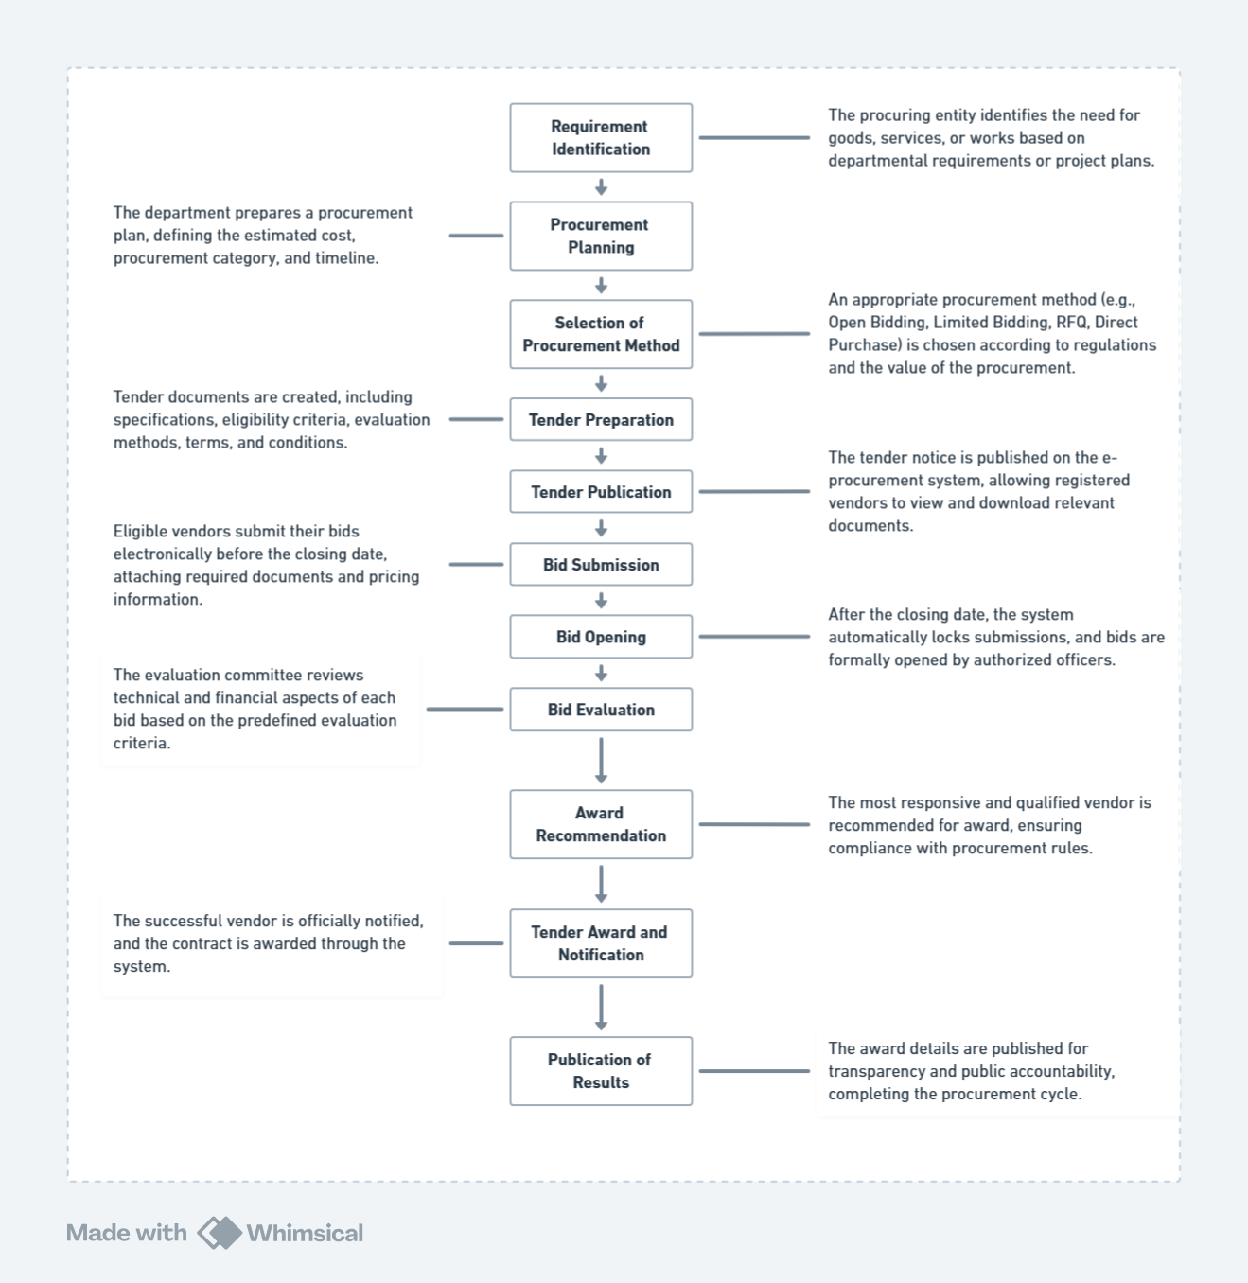
Figure 6.1 – System Flow Diagram
https://whimsical.com/2QWJHFWnj9xL99wedgGswz

6.1 Procurement Publishing
The process begins when a government ministry or department publishes a new procurement through the system.
Key steps include:
- Entering Primary Details such as Ministry, Department, Procurement Method, and Category.
- Selecting a CPV (Common Procurement Vocabulary) code for classification.
- Entering Quotation Number, Title, Estimation, and Funding Source.
- Publishing the Invitation for e-Quotation (IFeQ) with start, closing, and opening dates.
- Selecting a Process Template (standard or custom), which provides guidance and instructions based on the selected method.
- Adding Further Details, including the appointment of evaluation committees and other administrative data.

6.2 Vendor Interaction and Quotation Submission
Once a tender is published, registered vendors can view and participate in the process through their dashboards.
Vendors can:
- View Engaged and Active Procurements they are eligible for.
- Review IFeQ details and send clarifications or queries to the procuring entity.
- Prepare and submit their quotations digitally.
  - Upload Commercial Requirements documents.
  - Attach Certificates (such as business registration or compliance).
  - Upload Indications of Specifications and Bid Documents.
  - Complete and finalize their quotation submission before the deadline.

6.3 Transparent and Guided Process
Throughout the flow, the system ensures:
- Clear guidance at each step to reduce procedural errors.
- Secure and time-stamped submissions to maintain integrity and fairness.
- Simplified review and communication channels between vendors and procuring entities.

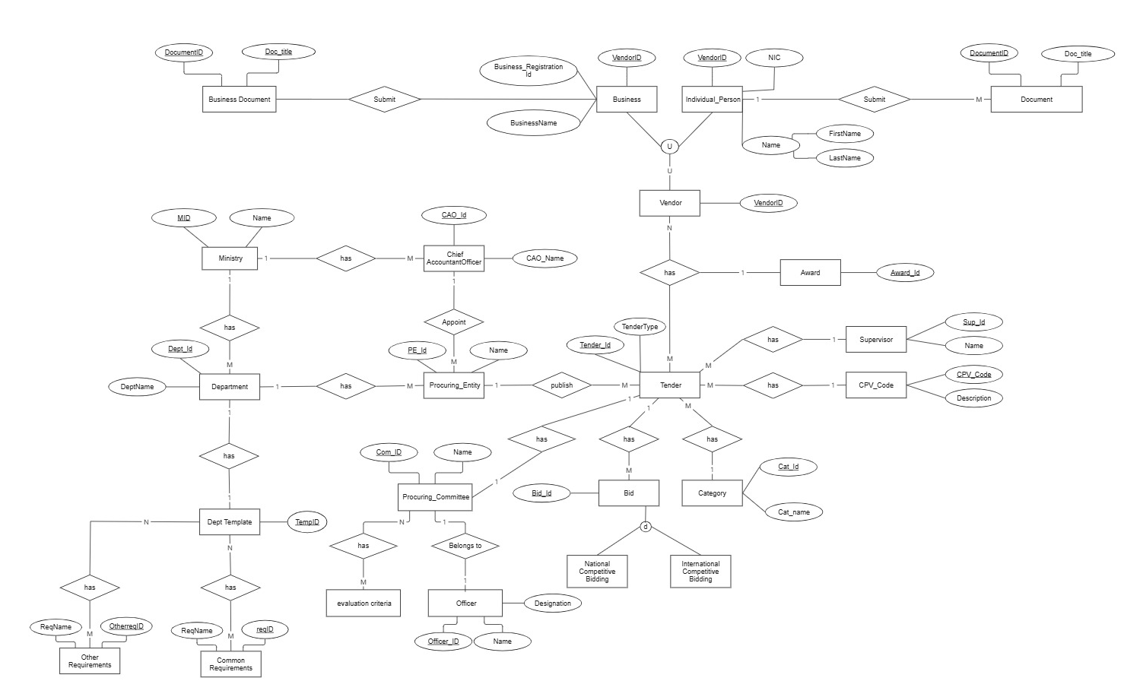
6.4 ER Diagram

Figure 6.2 – ER Diagram
https://miro.com/app/board/uXjVJ5uNCTo=/?share_link_id=971636692078

7. Technologies Used

7.1 Frontend Tech Stack

Area | Our Choice | Pros | Cons
Frontend Framework | Next.js | Huge ecosystem, SEO, Hybrid rendering | Slightly heavier than Remix/SvelteKit, learning curve for App Router
UI + Styling | Tailwind + shadcn/ui | Tailwind → utility-first (pre-defined classes), scalable  Shadcn → accessible, clean components, highly customizable with tailwind | Slightly more setup work, opinionated
Data Fetching & State | Zustand (for  global state) | Zustand → super minimal, fast  Easy to use than other libraries and community is bigger than other libraries except Redux toolkit. But it is easier to use than Redux toolkit. | Zustand lacks opinionated structure vs Redux
Form Validation | Zod | Zod → TS-first validation, New but old enough to stable.  Huge community than Yup. | Zod is still evolving compared to Yup. Yup was originally created for js.
HTTP Client | Axios | Interceptors, widely used | Slightly heavier than Fetch
Form Handling | Formik | Lightweight + TS-first validation | More boilerplate than Formik in simple forms
Internationalization | i18n, next-into | Built for Next.js, SSR-friendly, minimal boilerplate | Still maturing, smaller ecosystem than i18next
Unit Tests | Vitest + RTL | Mature ecosystem, widely adopted, works seamlessly with Next.js | Slightly slower than Vitest in larger projects

7.2 Backend Tech Stack

Area | Our Choice | Pros | Cons
Backend framework | Spring Boot V3. 5. 6 (Java V21) | Mature, enterprise-grade, huge ecosystem, strong type safety | Verbose compared to Node/Go: slower cold starts
Authentication | JWT, Auth 2.0
Caching & Queues | Redis and RabbitMQ
Database | PostgreSQL

7.3 Storage

Database – Postgre SQL
Object Storage – AWS S3

8. Novelty and Innovation

- Automated Vendor Registration Review
The system automatically validates vendor registration details and uploaded documents using AI-based verification techniques. This reduces the need for manual review and ensures only verified vendors proceed to the procurement stages.

- AI-powered chatbot that supports Conversational Search
Apart from typical search by category, value, location, and closing date, we are implementing a chatbot that supports Conversational Search. A natural language chatbot that allows users to simply ask, "Are there any new IT support tenders in the Western Province?"

- Context Bridge (Drag and Drop)
A user can perform a traditional search and see a list of tenders and They can then drag one or more tenders from the search results directly into the chatbot window. Once a tender is "dropped" into the chat, the user can immediately use pre-built AI tools or ask specific questions.

- AI Ranking and Recommendation System
Vendors are ranked based on historical performance, reliability, pricing trends, and compliance levels. The system uses AI to recommend the most suitable vendors for each procurement, improving the quality and fairness of the selection process.

- Smart Procurement Matching
Leveraging machine learning, the system intelligently matches new tenders with the most relevant vendors based on their business categories, past participation, and specialization. This ensures efficient tender distribution and higher vendor engagement.

- Automated Compliance Scoring
Before final submission, each quotation or bid is automatically checked for completeness and compliance against the tender’s requirements. The system generates a compliance score, enabling procurement officers to quickly identify valid and high-quality submissions.

- AI Document Summarizer
A built-in AI assistant summarizes lengthy tender documents and vendor proposals, providing concise overviews for procurement officers. This significantly reduces the time required for document analysis and decision-making.

- Auto generation Tender Notices

9. Work Allocation

9.1 Tender Publishing & Master Data Setup
(234132T – N. N. Moragoda)

Core Functional Work | Extra Responsibilities
- Build tender creation flow: Goods/Works/Services, NCB/ICB, dates, etc. | - Own master data setup (categories, agencies, codes like CPV/NIGP).
- Upload and store SBDs, agency templates. | - Design DB schema for tenders, documents, meetings, categories.
- Auto-generate tender notice/checklist. | - Create validation rules (mandatory fields, date ranges, etc.).
- Schedule clarifications/pre-bid meeting with calendar integration. | - Implement file versioning for tender documents.
 | - Automated Vendor Registration Review

9.2 Bidder Portal & Vendor Management
(234082M - H. G. C. S. Hulangamuwa)

Core Functional Work | Extra Responsibilities
- Vendor registration & KYC form (with category tagging). | - Build vendor profile management (update KYC, blacklist/whitelist vendors).
- Bid submission (upload docs, forms, BoQ, pricing). | - DB schema for vendors, kyc_docs, submissions, submission_files.
- Submission lock after deadline; generate proof of submission. | - Implement unique vendor ID & duplicate prevention logic.
 | - Handle email/SMS confirmations for submissions.
 | - AI-powered chatbot that supports Conversational Search

9.3 Clarifications & Addenda
(234129P - K. G. U. Mihiranga)
Core Functional Work | Extra Responsibilities
- Question/answer window for bidders - agency replies. | - Build notification service (email/SMS trigger when clarifications/addenda are posted).
- Publish clarifications visible to all bidders. | - DB schema for clarifications, clarification_replies, addenda_versions.
- Addenda/corrigenda publishing with version history & auto notifications. | - Implement document version control (hash + timestamp check).
 | - Manage audit logs for all Q&A and addenda changes.

9.4 Bid Opening & Evaluation
(234101A - D. S. Kankanamge)

Core Functional Work | Extra Responsibilities
- Time-boxed bid opening; attendance log. | - Build evaluation criteria setup module (pass/fail, weights, minimum scores).
- Multi-criteria evaluation (technical + financial). | - DB schema for opening_sessions, attendance, evaluations, scores.
- Weighted scoring models with consensus sheet generation. | - Implement committee workspace with role-based access (reviewer vs chair).
 | - Generate evaluation reports (PDF/Excel).

9.5 Award, Compliance & Reports
(234198A - S. T. N. Sirisooriya)
Core Functional Work | Extra Responsibilities
- Recommendation note & approvals chain. | - Implement post-award disclosure module (public access: winning bidder, contract value, justification).
- Award letter generation & notifications (winning + unsuccessful bidders). | - DB schema for awards, approvals, notifications, reports.
- Reports & dashboards: KPIs (cycle time, SME participation, award values). | - Build dashboard APIs (cycle time, bidder count, participation trends).
 | - Manage compliance rules (statutory retention, post-award data visibility).

Shared Responsibilities
- Auditability: Immutable logs (who/what/when), timestamps.
- Security: RBAC, MFA, field-level encryption.
- Search & Alerts: Keyword/category search, email/SMS alerts.
- Statutory Compliance: Retention rules applied to their domain's DB tables.

10. Expected Outcomes and Benefits

The proposed TenderEase.lk system is expected to transform the traditional tendering process into a fully digital, transparent, and efficient ecosystem. By integrating automation and AI-driven insights, the platform delivers the following key outcomes and benefits:

- Increased Transparency: Every stage of the procurement process is digitally recorded, ensuring full accountability and auditability.
- Faster Processing: Automated document validation and evaluation significantly reduce manual delays.

- Fair Vendor Selection: AI ranking and compliance scoring promote fairness and objectivity in tender awards.
- Reduced Administrative Workload: The system minimizes paperwork, data duplication, and human intervention.
- Enhanced Decision-Making: AI recommendations and summarized reports support data-driven procurement decisions.
- Better Vendor Engagement: Smart matching and clear communication channels encourage more qualified vendors to participate.
- Cost Savings: Efficient workflows and reduced manual errors lower overall operational costs for government departments.
- Data-Driven Insights: Centralized data allows departments to track performance trends and optimize procurement strategies.
- Secure and Scalable System: Cloud-based infrastructure ensures data integrity, accessibility, and scalability across ministries.
- Public Trust and Credibility: Transparent operations strengthen public confidence in the government’s procurement process.

11. Conclusion

The TenderEase.lk platform aims to modernize the government tendering and bidding process through smart automation, transparency, and AI innovation. By bridging the gap between vendors and government departments, it ensures a fair, efficient, and future-ready procurement system that sets a new digital standard for public sector operations.

References

Theekshana, “Promise.” https://promise.lk/

“eGP System Sri Lanka,” YouTube. https://www.youtube.com/@PromiseSriLanka

“Ministry of Finance - Sri lanka.” https://www.treasury.gov.lk/web/procurement-guidelines-and-manuals/section/procurement%20manual

Kalinga Gananath, “Procurement Process in Sinhala / ප්‍රසම්පාදන ක්‍රියාවලිය - සිංහලෙන්,” YouTube. Oct. 08, 2022. [Online]. Available: https://www.youtube.com/watch?v=YrMVWT6cMcA

“eRoc.” https://eroc.drc.gov.lk/home/company/verify

